POLITEINIK NEGERI MALANG

TEKNOLOGI INFORMASI

TEKNIK INFORMATIKA



#### Nama : Muhammad Nuril Huda

#### Kelas : TI-1A

#### No : 19

#### Mata Kuliah : Algoritma dan Struktur Data

Pertemuan 4 Quis

* Kode Program Cafe19

import java.util.Scanner;

public class Cafe19 {

    String namaPelanggan;

    String menuMakanan;

    String menuMinuman;

    String namaKasir;

    void tampilkanMenu(){

        System.out.println("=== Daftar Menu ===");

        System.out.println("---Makanan---");

        System.out.println("1. Nasi Goreng");

        System.out.println("2. Dimsum");

        System.out.println("3. Siomay");

        System.out.println("---Minuman---");

        System.out.println("1. Teh");

        System.out.println("2. Kopi");

        System.out.println("3. Thaitea");

    }

    void tambahMenu(Cafe19 [] arrayOfCafe){

        Scanner sc = new Scanner (System.in);

        for (int i=0;i<arrayOfCafe.length; i++){

            arrayOfCafe[i] = new Cafe19();

            System.out.println("=== Masukkan Menu Pelanggan ke-"+(i+1)+" ===");

            System.out.print("Nama Pelanggan\t: ");

            arrayOfCafe[i].namaPelanggan = sc.nextLine();

            System.out.print("Menu Makanan\t: ");

            arrayOfCafe[i].menuMakanan = sc.nextLine();

            System.out.print("Menu Minuman\t: ");

            arrayOfCafe[i].menuMinuman = sc.nextLine();

            System.out.print("Nama Kasir\t: ");

            arrayOfCafe[i].namaKasir = sc.nextLine();

            System.out.println("---------------------------");

        }

    }

    void cetakMenu (Cafe19 [] arrayOfCafe){

        for (int i=0; i<arrayOfCafe.length; i++){

            System.out.println("\n=== Daftar Menu Pelanggan ke-"+(i+1)+" ===");

            System.out.println("Nama Pelanggan\t: "+arrayOfCafe[i].namaPelanggan);

            System.out.println("Menu Makanan\t: "+arrayOfCafe[i].menuMakanan);

            System.out.println("Menu Minuman\t: "+arrayOfCafe[i].menuMinuman);

            System.out.println("Nama Kasis\t: "+arrayOfCafe[i].namaKasir);

        }

    }

}

* Kode Program CafeDemo19

import java.util.Scanner;

public class CafeDemo {

    public static void main(String[] args) {

        Scanner sc = new Scanner(System.in);

        System.out.print("Masukkan Jumlah Pelanggan: ");

        int pelanggan = sc.nextInt();

        Cafe19 [] arrayOfCafe = new Cafe19[pelanggan];

        Cafe19 cafe = new Cafe19();

        cafe.tampilkanMenu();

        cafe.tambahMenu(arrayOfCafe);

        cafe.cetakMenu(arrayOfCafe);

    }

}

* Hasil Run

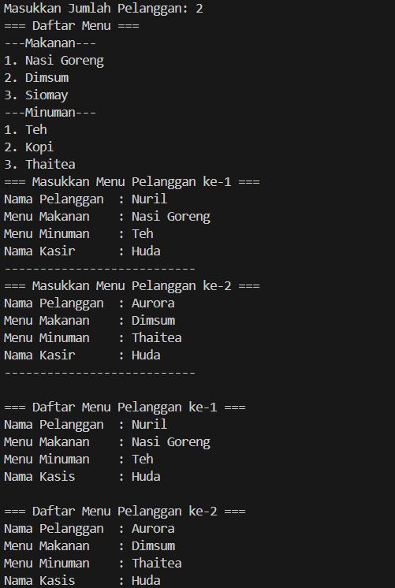

* Diagram Class

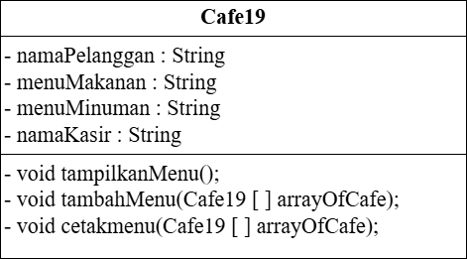

* Link Github

<https://github.com/nurilhuda05/Algoritma-dan-Struktur-Data/tree/5656df4b5d4c7a3fd6312711be4ca91e53a3020e/Pertemuan4_Quis>